Project Design Phase-II
Data Flow Diagram & User Stories
Date | 25 September 2026
Team ID | SWTID-2026-3161
Project Name | Script-Controlled ACL – Restrict Record Access Based on Field Value
Maximum Marks | 4 Marks

Data Flow Diagrams
A Data Flow Diagram (DFD) is a visual representation of the information flows within a system. The diagram below shows how an access request enters the Script-Controlled ACL system, how the field-value condition is evaluated, and where data is read from or written to.
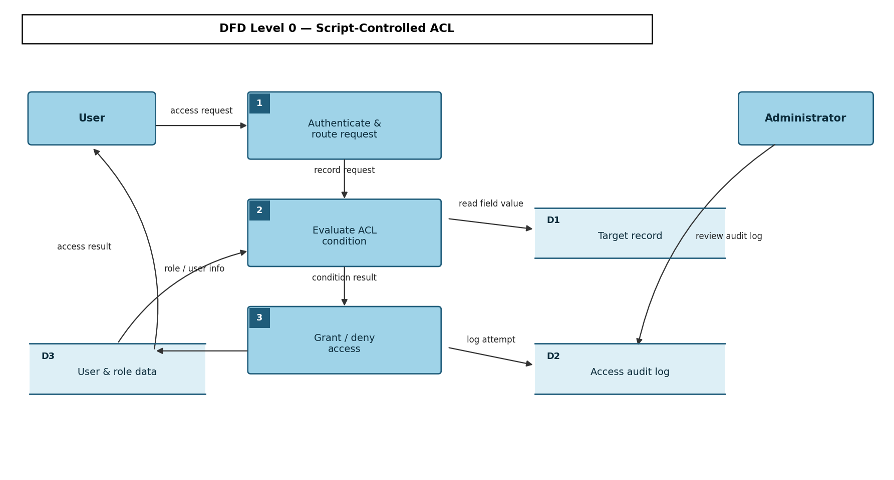

User Stories
The table below lists the user stories for the Script-Controlled ACL feature.
User Type | Functional Requirement (Epic) | User Story Number | User Story / Task | Acceptance Criteria | Priority | Release
Administrator | ACL rule configuration | USN-1 | As an administrator, I can create an ACL rule that restricts access based on a specific field value. | Rule is saved and enforced on the next access attempt. | High | Sprint-1
 |  | USN-2 | As an administrator, I can edit or disable an existing ACL rule. | Updated rule takes effect immediately without redeployment. | Medium | Sprint-1
 | Audit & monitoring | USN-3 | As an administrator, I can view an audit log of granted and denied access attempts. | Log shows user, record, field value, decision, and timestamp. | High | Sprint-2
Customer  (End user) | Record access | USN-4 | As a user, I can request to read or edit a record so the system checks my authorization automatically. | Access is granted or denied based on field value within acceptable response time. | High | Sprint-1
 |  | USN-5 | As a user, I receive a clear message when my access request is denied. | Denial message explains the reason without exposing internal rule logic. | Medium | Sprint-2
 | Notifications | USN-6 | As a user, I am notified if my access is repeatedly denied so I know to contact an administrator. | Notification is sent after a configurable number of consecutive denials. | Low | Sprint-2

